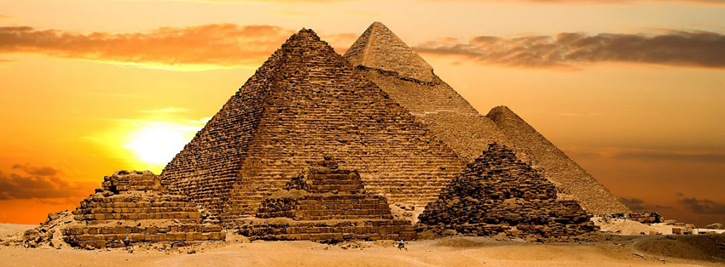

Come on down to the underworld and To enter you must simply step up to

see the magnificent pyramids and fertile soil the scales so we can measure your

we have to offer, being a parallel version of the soul compared to the feather of truth, if overworld it will feel just like home you have acted kindly don't fret, but if you have caused pain then Ammit will have his way with you.

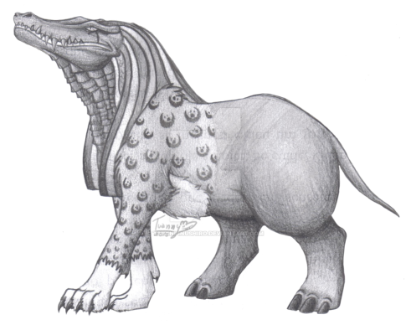 As it is made in the likeness of earth you can

visit the seven wonders of the world and travel to

the far corners of the world if you find the time

Fulfilling your "life" and feeling accomplished.

Once admitted you must live as if on earth, tending to the crops and animals or ruling your kingdom in paradise!